how to store script files on storage account and use the script on cloudshell to create vm

step 1-

create a storage account.

Enabled managed identity authentication.

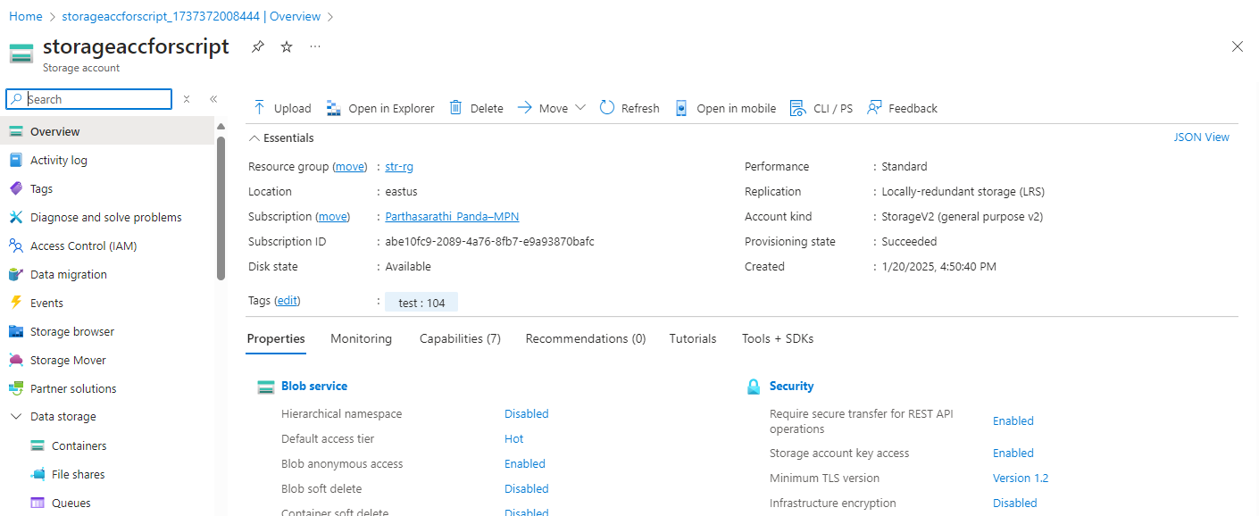

Step 2-

Create a file share for uploading and storing script file to it.

Step 3-

Create sript file, that can create a vm.

Script-

az vm create \

  --resource-group "str-rg" \

  --name "myvm1" \

  --image "Ubuntu2404" \

  --admin-username "partha" \

  --admin-password "1admin@Password"

Note this is bash script.

Before processing, run the script and make sure it works.

May be image issue or username condition password condition issue etc..

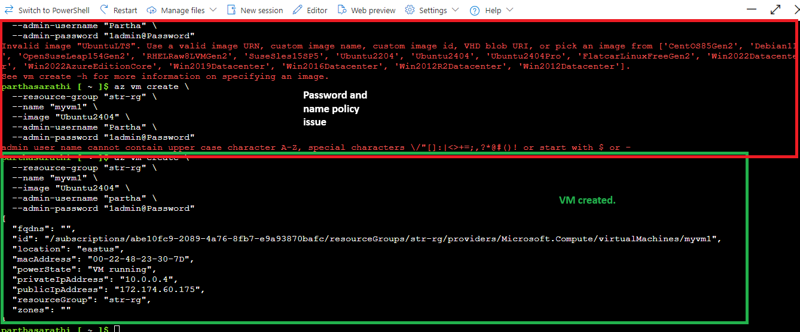

Save the script file with “.sh” extension.

Step 4-

Upload the script file to file share.

Faced issue to upload the script. Tried with another file that also failed.

I guess this issue due to we make it identity managed verification.

Let’s assign IAM role for the user.

Assigned contributor access for the file share.

Still same issue. Assigned another permission “Storage File Data SMB Share Elevated Contributor”.

Same issue-

If I see it’s not enabled here.

Failed to do. Due to reason

Let’s create new storage account and do.

This time did not choose Entra id authentication.

Upload the file.

Uploaded successfully.

Step 5-

Open cloud shell.

Directly upload the script file here and try

Assign permission for the file and run

Worked successfully.

Step 6-

To use storage files in cloudshell, cloudshell must be mount with str.

We can check that by running cmd on cloudshell – powershell

>> dir

It must show the clouddrive.

If it’s shows Microsoft or something different. That means str is not attached to cloudshell.

That’s depends on our choice while we start cloud shell.

If by chance your storage is not attached or your script is in some different storage. You can detach the cloudshell and attached to another storage account to use that acount’s file share.

Cloudshell use file share to proceed to create directory and other uses.

To do this **Reset Cloud Shell from Azure Portal**: You can reset your Cloud Shell environment directly from the Azure portal:

* + Go to the Azure Portal.
  + Open the Cloud Shell.
  + Click on the settings icon (gear icon) and select "Reset Cloud Shell".

Once you reset it will ask how do you want to proceed, with your storage account or without that.

Choose your subscription to use storage account.

Go with your choice. Either you want to create new storage account or use existing one.

Select the storage account and file share where the script is stored and want to use.

It will deploy cloud shell for our use.

Test cloudshell is added

>> dir

Step 7-

To use storage file share navigate to cloud drive.

>> cd ./clouddrive/

Check the list of scripts available.

>> ls

Give executive permission to script if it don’t have.

>> sudo chmod 777 filename

>> ls -l

Step 8-

Run script and test.



The issue is our script is a bash script. Run it from bash.

Switch to bash

Script worked and vm created.

